TestNG with Maven

1. Create simple Maven project
2. In pom.xml file add reference to TestNG

<dependency>

<groupId>org.testng</groupId>

<artifactId>testng</artifactId>

<version>6.8</version>

<scope>test</scope>

</dependency>

1. Add a class file under src/test/java

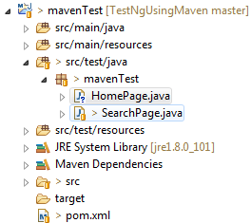

1. Write required test cases and decorate that with testing annotation @Test
2. Right click the class file 🡪 TestNG 🡪 Convert To TestNG

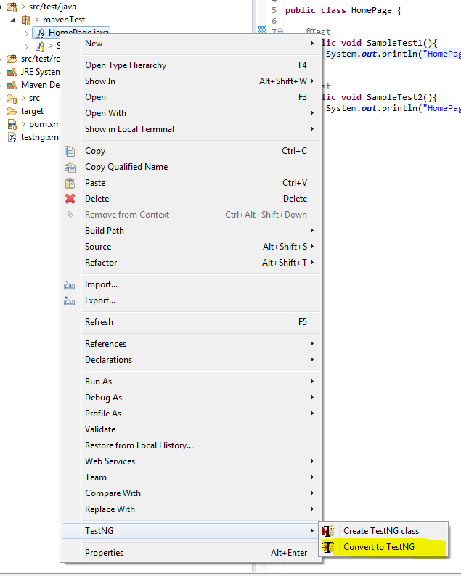

1. Give the required path where do you want to save the .xml file

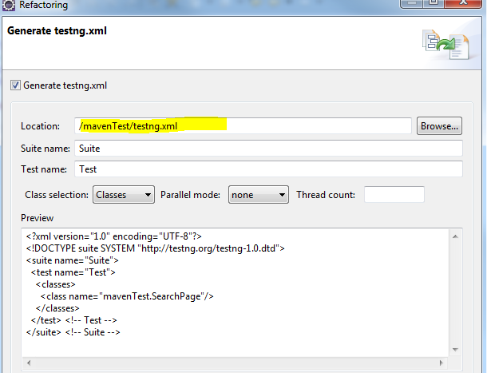

1. The below screenshot shows testing xml files are stored under “src/test/resources” folder

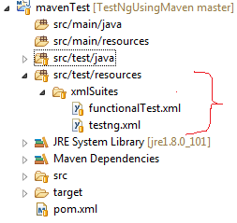

1. Ways of running test cases
2. By right clicking the .xml file you can run the tests as TestNG Suite



1. By right clicking the pom.xml file : Run As 🡪 Maven install

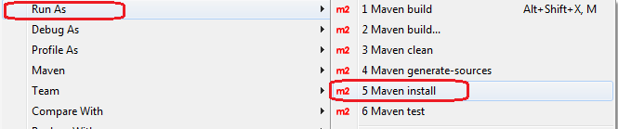

1. In command window
   1. navigate to the folder under which we have pom.xml file
   2. type the command: mvn clean install

To get Maven test result in HTML file

In pom.xml file add below tags to get test execution result in HTML format

<reporting>

<plugins>

<plugin>

<groupId>org.apache.maven.plugins</groupId>

<artifactId>maven-surefire-report-plugin</artifactId>

<version>2.19.1</version>

</plugin>

</plugins>

</reporting>

The execution result will be stored under the target folder

